# Table of Contents

1. Abstract 3
2. Introduction 4
3. Definitions and Acronyms 4
4. Proposed system 5
5. Feasibility report 5
   1. General requirement feasibility report 5
   2. Problem in the current system 6
6. Technical feasibility 6
7. Technical description 6
8. Graphical user interface 7
9. Project Design Description 7
   1. Purpose 7
   2. Scope 7
10. Functional requirements 8
11. Performance requirements 8
12. Scope of the development project 9
    1. Database tier 9
    2. User tier 9
    3. Database connectivity tier 9
13. Software requirement specification 10
    1. Requirement hardware 10
    2. Requirement software 10
14. Modules description 10
    1. Accommodation information 10
    2. Units information 11
    3. Booking module 11
    4. Guest module 11
    5. Facilities module 11
15. Number of views 11
    1. Administrative view 11
    2. Guest view 12
16. Performance requirements 12
17. Front end or User interface design 13
18. Dataflow diagrams 14
19. E-R-Diagrams 15
20. Unified modeling language diagram 16
21. Sequence diagrams 18
22. Testing 19
23. Installation and project description 20
24. Conclusions and recommendations 24
25. Acknowledgements 25
26. References 26

# Abstract

The system aims at the maintenance and management of the different Hotels that are available in the different parts of the world. It mainly takes care of the Hotel management at the core area of the database. The system provides the information regarding the different Hotels that are available and their status specific to availability. The guests can visit the site and register themselves with the required information that is expected by the system. Each registered guest can raise a request for the unit bookings. The Guests are scheduled with the information of the availability of the units for they have requested the time.

The total front end was dominated using HTML standards applied with the dynamism of JAVA server pages. The communicating client was designed using servlet and JSP’s. At all proper levels high care was taken to check that the system manages the date consistency with proper business validations. The database connectivity was planned using the Java Data Base Connectivity , the authorization and authorization was cross checked at all stages. The user level accessibility has been restricted into two zones the administrative and the normal user zone.

# Introduction

The entire project has been develped keeping in view of the Distributed client server computing technology in mind.The specification have been normalized upto 3NF to eliminate all the anomalies that may arise due to the database transactions that are executed by the actual administration and users.The user interfaces are browser specific to give distributed accessability for the overall system.The internal database has beeb selected as Oracle 11g.The basic constructs of the tablespaces,clusters and ridexes have been exploited to provide higher consistency and reliability for the data storage.

The oracle 11g was a choice as it provides the constructs of high level reliabiity and security.The total front end was dominated using HTML standards applied with the dynamism of JAVA server pages. Thecommunicatin client was designed using servlets. At all proper levels high care was taken to check that the system manages the date consistency with proper business validations.The database connectivity was planned using the Java DataBase Connectivity,the authorization and authorization was cross checked at all stages.The user level accessabiity has been restricted into two zones the administrative and the normal user zone.

# Definitions and Acronyms.

HTTP- Hypertext transfer Protocol HTML- Hypertext Markup Language FR – Functional Requirement

NFR –Nonfunctional requirement GUI – Graphical user interface

OSGI- Open Services Gateway initiative.

# Proposed System:

The Automated system with distributed architecture can support issues like.

1. The system maintains the different location that are available and registered in a central DB, which leads easy accessibility and consistency.
2. Each Accommodation available units and all the unit facilities are also available at the click of a mouse.
3. The registration of new guest is online house new guest can make them they convenient for registration process on the basic of 24x7x326days.
4. The Units can be booked by the Registered guest irrespective of the Geographical barriers.
5. The Guest are provided with up to minute information related to the unit availability and their status. From their convenient place.
6. The decision process in more faster and more consistent.
7. The guest have information at their demand related to any unit status of their own unit booking status.

# FEASIBILTY REPORT

* 1. **GENERAL REQUIREMENTS FEASIBILTY REPORT:**
* The new system should be cost effective
* To improve productivity and service and service.
* To enhance user interface.
* To improve information presentation and durability.
* To upgrade systems reliability, availability and flexibility.
* To address human factors for better and uses acceptance.

# PROBLEM IN THE CURRENT SYSTEM:

The present system is presently is an undeveloped form and the manual process of the overall system is too clumsy and complicated. The clients in the real time consultancy system can be too thick and may need many resources to be used upon the system. If the system is developed, in a distributed over interface with centralized database is the only solution.

# TECHINICAL FEASIBILITY:

Evaluating the technical feasibility is the trickiest part of a feasibility study. This is because, at this point in time, not too many detailed design of the system, making it difficult to access issues like performance, costs on (on account of the kind of technology to be deployed) etc. A number of issues have to be considered while doing a technical

Analysis :

* + Understand the different technologies involved in the proposed system .
  + Before commencing the project, we have to be very clear about what are the technologies that are to be required for the development of the new system.
  + Find out whether the organization currently possesses the required technologies

# Technical Description

The total number of databases that were identified to build the system is 10. The major part of the Databases is categorized as Administrative components and the user components.

The administrative components are useful is managing the actual master data that may; be necessary to maintain the consistency of the system. The administrative databases are purely used for the internal organizational needs and necessities.

The user components are designed to handle the transactional state that arise upon the system whenever the general client makes a visit onto the system for the sake of the report based information.

The user components are scheduled to accept parametrical information for the user as per the systems necessity.

# GRAPHICAL USER INTERFACE

For the flexibility of the user, the interface has been developed in graphical user interface mode. The normal interface is applied through browser.

The GUI’s at the top level has been categorized as:

1. Administrative user interface
2. Customer or general user interface

The administrative user interface concentrates on the consistent information that is practically, pact of the organizational activities and which needs proper authentication for the data collection. The interfaces help the visitors with all the transactional states like Data insertion, Data deletion and Data updating with the data search capabilities.

The general user interface helps the users upon the system in transactions through the required services that are provided upon the system. The general user interface also helps the ordinary user is managing their own information in a customized manner as per their flexibilities.

# Project Design Description

# Purpose:

The main purpose for preparing this document is to give a general insight into the analysis and requirements of the existing system or situation and for determining the operating characteristics of the system.

# Scope:

This Document plays a vital role in the development life cycle (SDLC) As it describes the complete requirement of the system. It is meant for use by the developers and will be the

basic during testing phase. Any changes made to the requirements in the future will have to go through formal change approval process.

1. **Functional Requirements**: Inputs:

The major inputs for Integration of Web based Accommodation Upholding Maintenance System can be categorized module -wise.

Basically all the information is managed by the software and in order to access the information one has to produce one's identity by entering the user-id and password.

Every user has their own domain of access beyond which the access is dynamically refrained rather denied.

Output:

The major outputs of the system are tables and reports. Tables are created dynamically to meet the requirements on demand.

Reports, as it is obvious ,carry the gist of the whole information that flows across the institution. This application must be able to produce output at different modules for different inputs.

# Performance Requirements:

Performance is measured in terms of reports generated weekly and monthly. Intended Audience and Reading Suggestions

The document is prepared keeping is view of the academic constructs of my Bachelors Degree / Masters Degree from university as partial fulfillment of my academic purpose the document specifies the general procedure that that has been followed by me, while the system was studied and developed.

The general document was provided by the industry as a reference guide to understand my responsibilities in developing the system, with respect to the requirements that have been pin pointed to get the exact structure of the system as stated by the actual client.

The system as stated by my project leader the actual standards of the specification were desired by conducting a series of interviews and questionnaires.

The collected information was organized to form the specification document and then was modeled to suite the standards of the system as intended.

# Scope of The Development Project:

# Database Tier:

The concentration is applied by adopting the Oracle 9i Enterprise versions. SQL is taken as the standard query language. The overall business rules are designed by using the power of PL/SQL components like stored procedures stored functions and database triggers.

# User Tier:

The use interface is developed is a browses specific environment to have distributed architecture. The components are designed using HTML standards and Java server pages power the dynamic of the page design.

# Data Base Connectivity Tier:

The communication architecture is designed by concentrated on the standards of servlets and JSP’s. The database connectivity is established using the Java Database connectivity.

# Software Requirement Specification

* 1. **Required Hardware**
     + Pentium IV Processor.
     + 512 MB RAM.
     + 20 GB Hard Disk space.
     + Ethernet card with an Internet and Internet zone**.**

# Required Software

* + - Windows 8 operating system.
    - Internet explorer11 and Netscape navigator.
    - Oracle 11g.
    - Servlets
    - JSP
    - TCP/IP Protocol suite.

# Modules Description

Number of Modules:

* Accommodation Information Module
* Units Information Module.
* Bookings Information Module.
* Guests Information Module.
* Facilities Information Module.

# ACCOMMODATION INFORMATION:

This module maintains all the details of the Accommodation location that are available and the units that are available under each location along with their reference unit types.

# UNITS INFORMATION:

This module maintains the information regarding all the units that are registered as per specifications and their reference unit types. The module also takes care of the system from the unit facilities and reference unit facilities that are available.

# BOOKING MODULE:

This module maintains the information of all the booking of the units, as pet the guest requirements, it searches itself with the units station database and the specific registered guest who have raised the demand upon the booking.

# GUEST MODULE:

This module maintains the overall activities through which a guest is uniquely registered is the domain the module interpreter with the specific gender status and also centrally sets with interpretation through booking and registry to unit status.

# FACILITIES MODULE:

This module maintains the overall activities in the facilities that are available are provided fn all or some of the specified units. This module helps in registering the reference unit facilities that may creep in into the system from time to time.

# NUMBER OF VIEWS:

* Administrative View
* Guest View

# Administrative View

This view is designed for interacting with the absolute Meta Data, which becomes the ultimate repository to maintain the consistency.

This view is accessible only to registered administrators who are recognized by the Watershed Development central Administration Department.

access.

This Module takes care of the responsibility of the major Table management for

* Data Insertion
* Data Deletion
* Data Updating
* Data Selection

All the activities are validated and authenticated to proper profile to avoid un authorized

# Guest View

In this view the guest can view complete details of available accommodation list information.

# Performance Requirements:

Performance is measured in terms of reports generated weekly and monthly. Intended Audience And Reading Suggestions

The document is prepared keeping is view of the academic constructs of my Bachelors Degree / Masters Degree from university as partial fulfillment of my academic purpose the document specifies the general procedure that that has been followed by me, while the system was studied and developed. The general document was provided by the industry as a reference guide to understand my responsibilities in developing the system, with respect to the requirements that have been pin pointed to get the exact structure of the system as stated by the actual client.

The system as stated by my project leader the actual standards of the specification were desired by conducting a series of interviews and questionnaires. The collected information was organized to form the specification document and then was modeled to suite the standards of the system as intended.

# Front end or User Interface Design

The entire user interface is planned to be developed in browser specific environment with a touch of Intranet-Based Architecture for achieving the Distributed Concept.

The browser specific components are designed by using the HTML standards, and the dynamism of the designed by concentrating on the constructs of the Java Server Pages.

# Data Flow Diagrams

* This Diagram server two purpose.
* Provides an indication of how date is transformed as it moves through the system.
* Disputes the functions and sub functions that transforms the dataflow.



**Admin**

**WEB BASED**

**ACCOMODATIO N**

**UPHOLDING SYSTEM**

**Guest**

**Accommodation Info**

**Units Info**

**Booking Info**

**Guests**

**Facilities Info**

# ER-Diagrams

The entity Relationship Diagram (ERD) depicts the relationship between the data objects. The ERD is the notation that is used to conduct the date modeling activity the attributes of each data object noted is the ERD can be described resign a data object descriptions.

The set of primary components that are identified by the ERD are

* Data object  Relationships
* Attributes  Various types of indicators.

The primary purpose of the ERD is to represent data objects and their relationships.

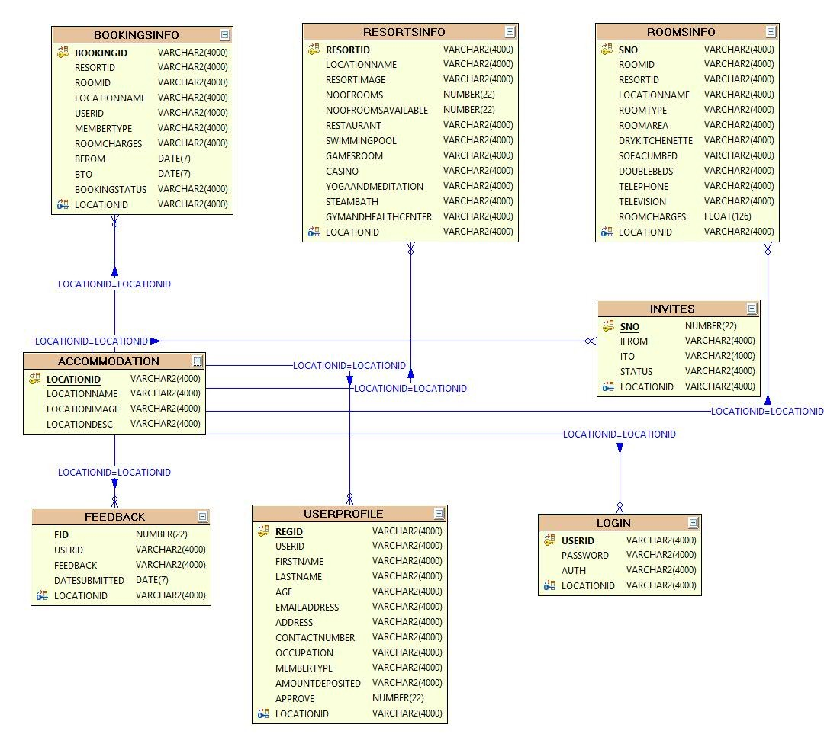

# Unified Modeling Language Diagrams

The unified modeling language allows the software engineer to express an analysis model using the modeling notation that is governed by a set of syntactic semantic and pragmatic rules.

A UML system is represented using five different views that describe the system from distinctly different perspective. Each view is defined by a set of diagram, which is as follows**.**

* User Model View :

1. This view represents the system from the users perspective.
2. The analysis representation describes a usage scenario from the end-users perspective.

* Structural model view :

1. In this model the data and functionality are arrived from inside the system.
2. This model view models the static structures**.**

* Behavioral Model View :

a. It represents the dynamic of behavioral as parts of the system, depicting the interactions of collection between various structural elements described in the user model and structural model view**.**

* Implementation Model View :

1. In this the structural and behavioral as parts of the system are represented as they are to be built.

* Environmental Model View :
  1. In this the structural and behavioral aspects of the environment in which the system is to be implemented are represented.

# SEQUENCE DIAGRAMS

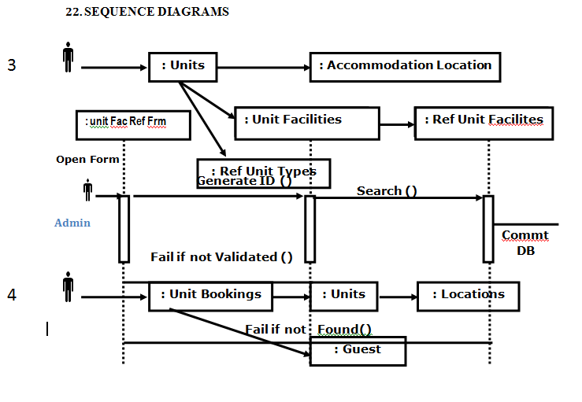

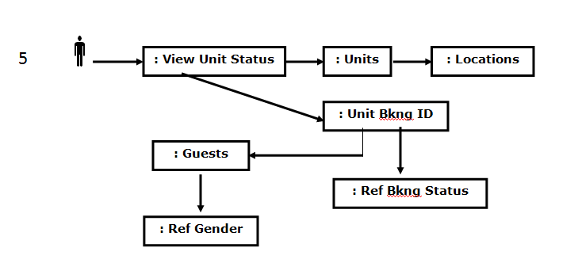

# Testing

Testing is the process of detecting errors. Testing performs a very critical role for quality assurance and for ensuring the reliability of software. The results of testing are used later on during maintenance also.

Psychology of Testing :

The aim of testing is often to demonstrate that a program works by showing that it has no errors. The basic purpose of testing phase is to detect the errors that may be present in the program. Hence one should not start testing with the intent of showing that a program works, but the intent should be to show that a program doesn’t work. Testing is the process of executing a program with the intent of finding errors.

Testing Objectives:

The main objective of testing is to uncover a host of errors, systematically and with minimum effort and time. Stating formally, we can say

* Testing is a process of executing a program with the intent of finding an error.
* A successful test is one that uncovers an as yet undiscovered error.
* A good test case is one that has a high probability of finding error, if it exists.
* The tests are inadequate to detect possibly present errors.
* The software more or less confirms to the quality and reliable standards.

Levels of Testing:

In order to uncover the errors present in different phases we have the concept of levels of testing. The basic levels of testing are as shown below…

Client Needs



Acceptance Testing

Requirements



System Testing

Design



Integration Testing



Unit Testing

Code

# Installation and project description

The database as it is developed by oracle 11g can be installed only by using the export and import concepts.

Using core java and components like JSP and Servlets needs proper deployment as per general specifications developed the front end as it.

The project can be described by the screenshots in the project as follows The following screenshots appear when the admin login to the browser :

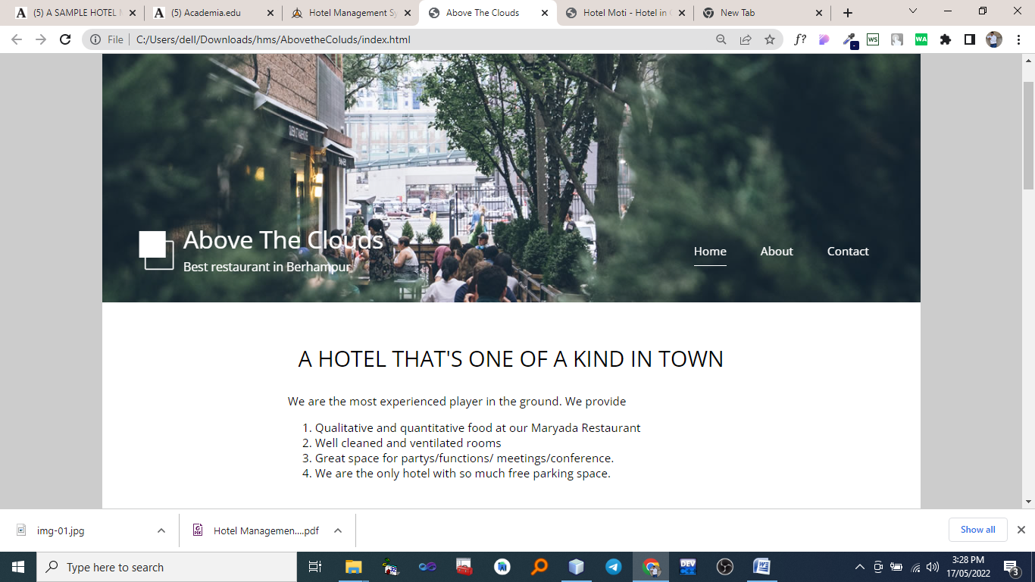

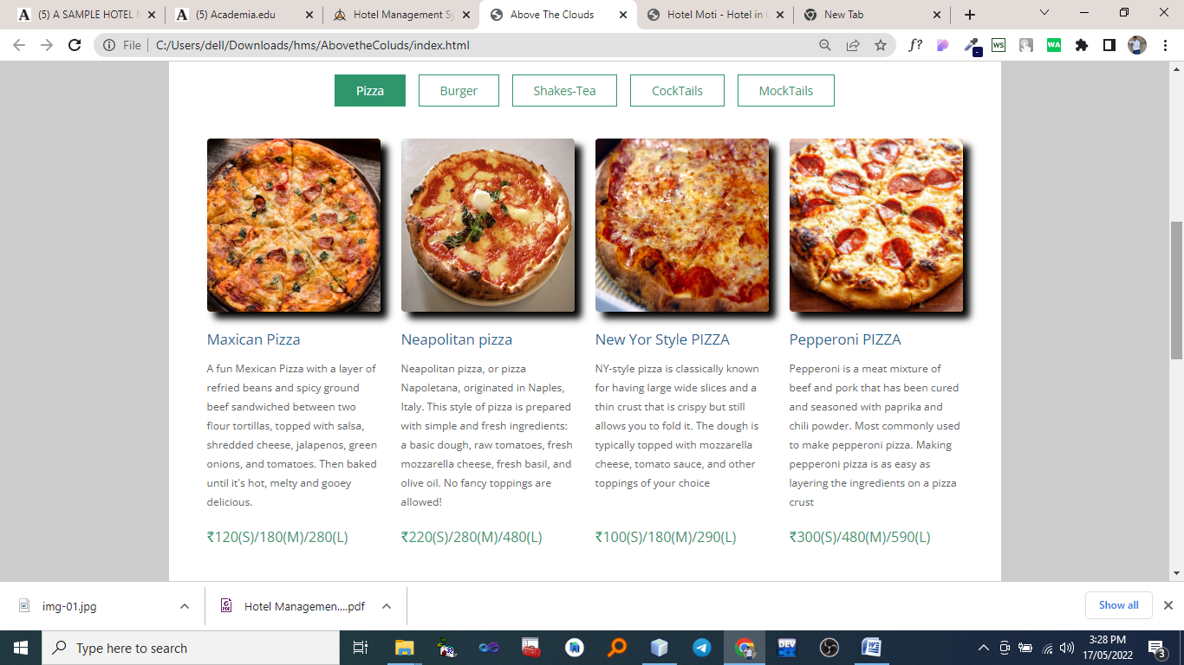

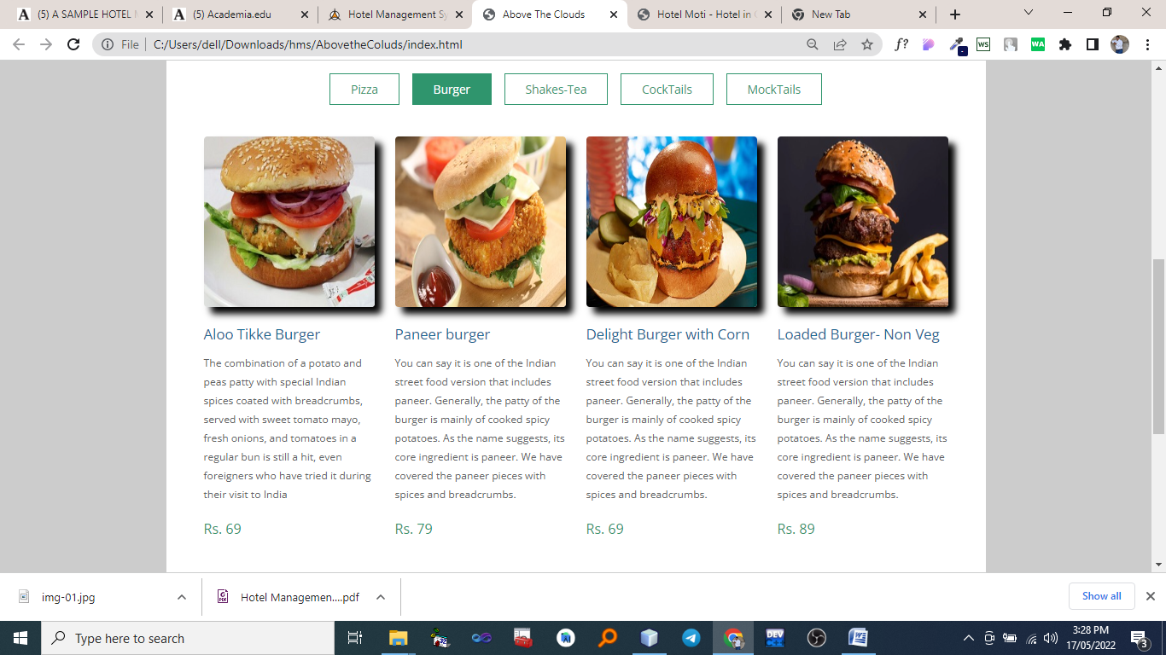

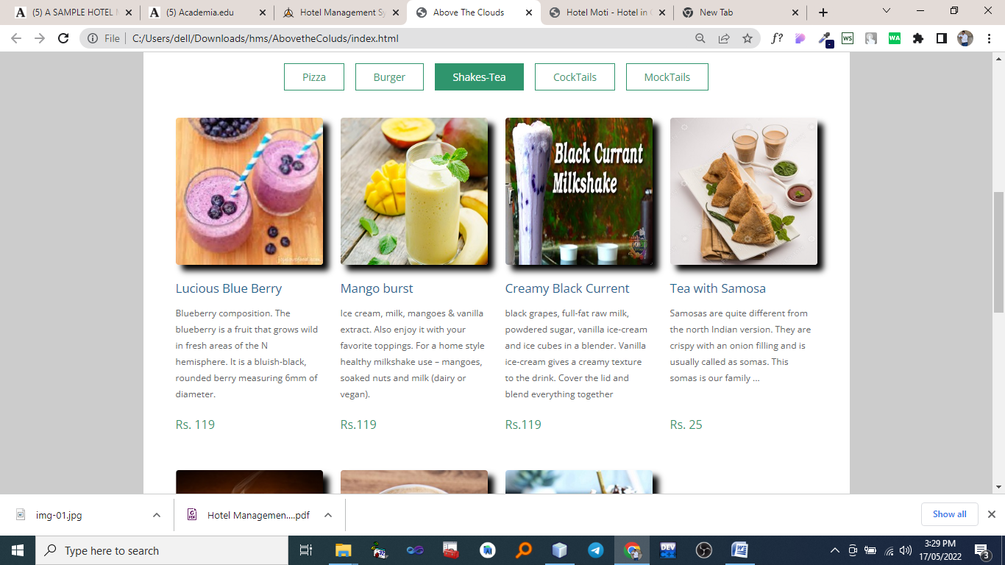

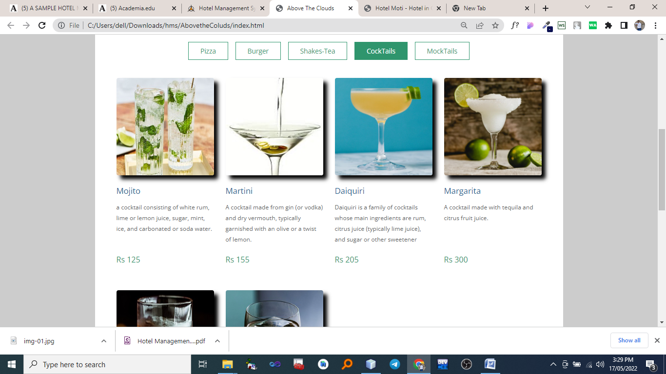

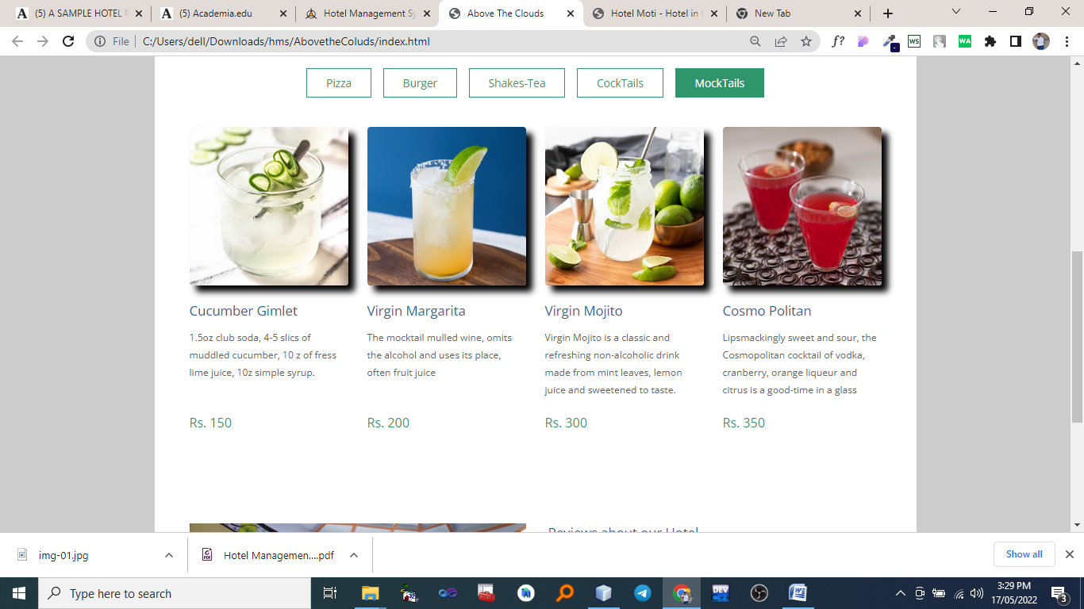

# Conclusions And Recommendations

The entire project has been developed and deployed as per the requirements stated by the user, it is found to be bug free as per the testing standards that are implemented. Any specification untraced errors will be concentrated in the coming versions, which are planned to be developed in near future.

The system at present does not take care of the money payment methods, as the consolidated constructs need SSL standards and are critically to be initiated in the first face, the application of the credit card transactions is applied as a developmental phase in the coming days. The system needs more elaborative technicality for its inception and evolution.

# Acknowledgements:

I have taken efforts in this project. However, it would not have been possible without the kind support and help of many individuals and organizations. I would like to extend my sincere thanks to all of them.

I am highly indebted to for their guidance and constant supervision as well as for providing necessary information regarding the project & also for their support in completing the project.

I would like to express my gratitude towards my parents & member of for their kind co- operation and encouragement which help me in completion of this project.

# References :

Steven Feuerstein, Bill Pribyl ., PL/SQL Programming, O’Reilly Media, 2014 Jon Duckett ., Java Script Programming, Wiley, 2014

Elliotte Rusty Harold ., JAVA Networking, O’Reilly Media, 2010 Rene Enriquez ., JAVA Security, Packt Publishing, 2014

Bryan Basham, Kathy Sierra ., Head First EJB ,O'Reilly Media; Second edition, 2008 Shadab siddiqui., J2EE Professional, Premier Press; 1 edition, 2002

Joel Murach, Michael Urban., JAVA servlets, Mike Murach, 2014

Kogent Learning Solutions INC., HTML 5 Black Book, Dreamtech Press, 2011